Defect ID:  (Required) | BCR-001
Author:  (Required) | Israel M. Vinuya
Release/Build #  (Required) | R1.0
Open Date:  (Required) | 10-Mar-2022
Close Date:
(Required)
Defect or Enhancement:  (Required) | Defect (Default)  Enhancement
Problem Title:  (Required) | Buggy Rating link is broken in Popular Make page
Problem Description:  (Required) | Steps to Replicate:  - Open https://buggy.justtestit.org/  - Click Popular Make graphic  - Click Buggy Rating link in the header  Screenshot:  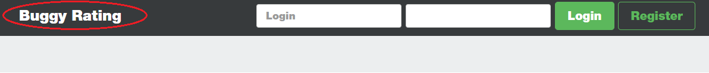  Expected Result:  - Buggy Rating link in the header should take you back to the Home page  Actual Result:  - Buggy Rating link is broken
Current Environment:  (Required) | TEST
Defect Type:  (Required) | Functionality (Default)  Architectural  Connectivity  Consistency  Database Integrity  Documentation  GUI  Installation  Memory  Performance  Security and Controls  Standards and Conventions  Stress  Usability
Who Detected:  (Required) | Quality Assurance (Default)  External Customer  Internal Customer  Development
How Detected:  (Required) | Testing (Default)  Review  Walkthrough  JAD
Assigned To:  (Required) | BCR Dev Team
Priority:  (Required) | High (Default)  Critical  Medium  Low
Severity:  (Required) | High (Default)  Critical  Medium  Low
Status:  (Required) | Open (Default)  In Progress  Resolved  Ready for Testing  Closed  Reopened
Fixed by:
Planned Fix Build #:

Defect ID:  (Required) | BCR-002
Author:  (Required) | Israel M. Vinuya
Release/Build #  (Required) | R1.0
Open Date:  (Required) | 10-Mar-2022
Close Date:
(Required)
Defect or Enhancement:  (Required) | Defect (Default)  Enhancement
Problem Title:  (Required) | Model and Rank links are not sorting in Popular Make page
Problem Description:  (Required) | Steps to Replicate:  - Open https://buggy.justtestit.org/  - Click Popular Make graphic  - Click Model or Rank link  Screenshot:  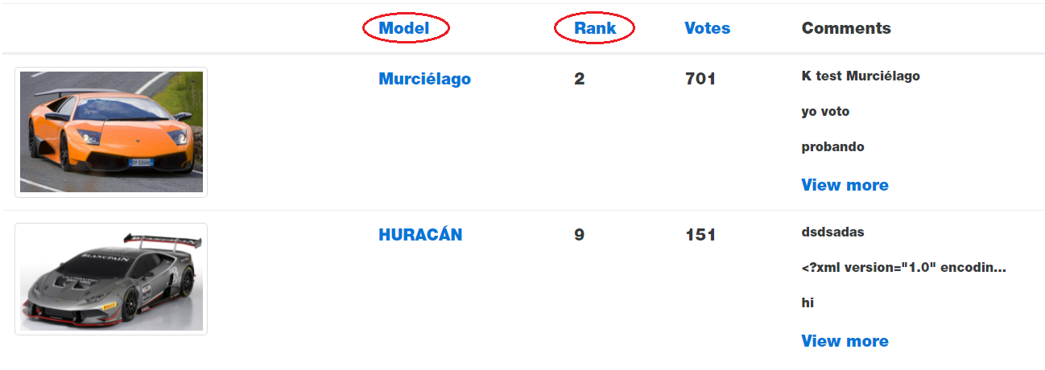  Expected Results:  - When Model link is clicked, list will be sorted by Model  - When Rank link is clicked, list will be sorted by Rank  Actual Result:  - Nothing happens when Model or Rank link is clicked
Current Environment:  (Required) | TEST
Defect Type:  (Required) | Functionality (Default)  Architectural  Connectivity  Consistency  Database Integrity  Documentation  GUI  Installation  Memory  Performance  Security and Controls  Standards and Conventions  Stress  Usability
Who Detected:  (Required) | Quality Assurance (Default)  External Customer  Internal Customer  Development
How Detected:  (Required) | Testing (Default)  Review  Walkthrough  JAD
Assigned To:  (Required) | BCR Dev Team
Priority:  (Required) | High (Default)  Critical  Medium  Low
Severity:  (Required) | High (Default)  Critical  Medium  Low
Status:  (Required) | Open (Default)  In Progress  Resolved  Ready for Testing  Closed  Reopened
Fixed by:
Planned Fix Build #:

Defect ID:  (Required) | BCR-003
Author:  (Required) | Israel M. Vinuya
Release/Build #  (Required) | R1.0
Open Date:  (Required) | 10-Mar-2022
Close Date:
(Required)
Defect or Enhancement:  (Required) | Defect (Default)  Enhancement
Problem Title:  (Required) | Sorting of Rank is not numerical in Overall Rating page
Problem Description:  (Required) | Steps to Replicate:  - Open https://buggy.justtestit.org/  - Click Overall Rating graphic  - Click Rank link  Screenshot:  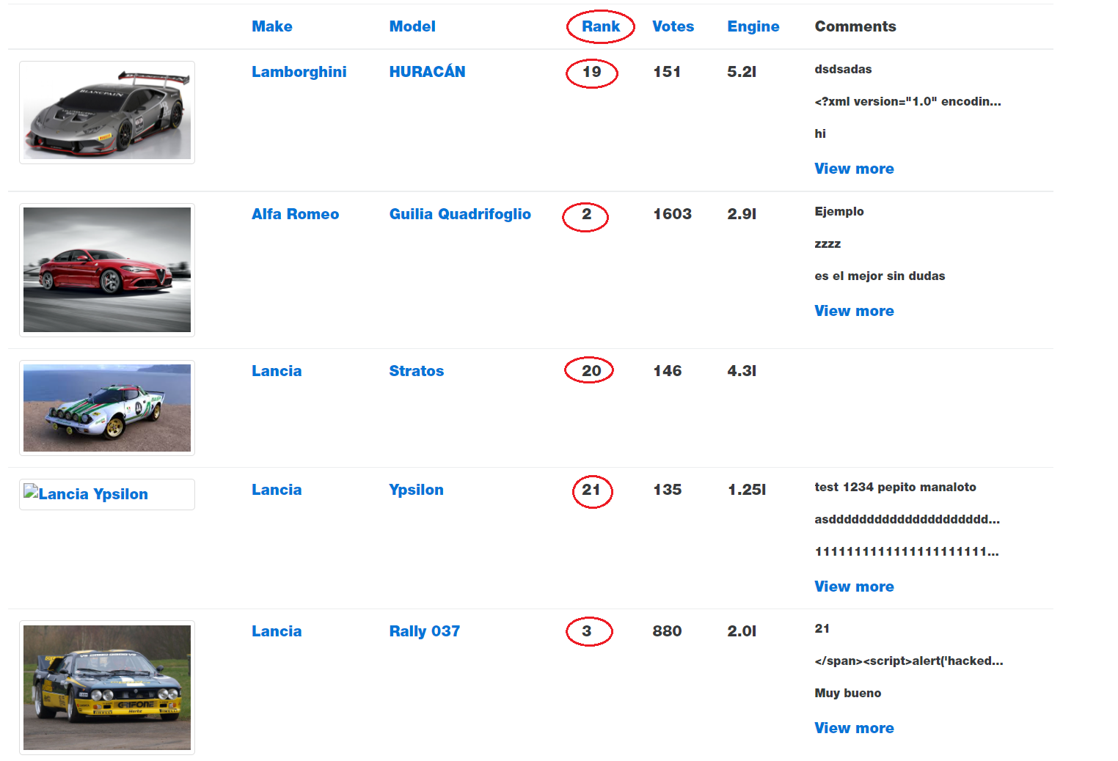  Expected Result:  - When Rank link is clicked the sorting should be numerical order  Actual Result:  - When Rank link is clicked text sorting is implemented
Current Environment:  (Required) | TEST
Defect Type:  (Required) | Functionality (Default)  Architectural  Connectivity  Consistency  Database Integrity  Documentation  GUI  Installation  Memory  Performance  Security and Controls  Standards and Conventions  Stress  Usability
Who Detected:  (Required) | Quality Assurance (Default)  External Customer  Internal Customer  Development
How Detected:  (Required) | Testing (Default)  Review  Walkthrough  JAD
Assigned To:  (Required) | BCR Dev Team
Priority:  (Required) | High (Default)  Critical  Medium  Low
Severity:  (Required) | High (Default)  Critical  Medium  Low
Status:  (Required) | Open (Default)  In Progress  Resolved  Ready for Testing  Closed  Reopened
Fixed by:
Planned Fix Build #:

Defect ID:  (Required) | BCR-004
Author:  (Required) | Israel M. Vinuya
Release/Build #  (Required) | R1.0
Open Date:  (Required) | 10-Mar-2022
Close Date:
(Required)
Defect or Enhancement:  (Required) | Defect (Default)  Enhancement
Problem Title:  (Required) | Lancia Ypsilon has a broken image in Overall Rating page
Problem Description:  (Required) | Steps to Replicate:  - Open https://buggy.justtestit.org/  - Click Overall Rating graphic  - Click Lancia link  Screenshot:  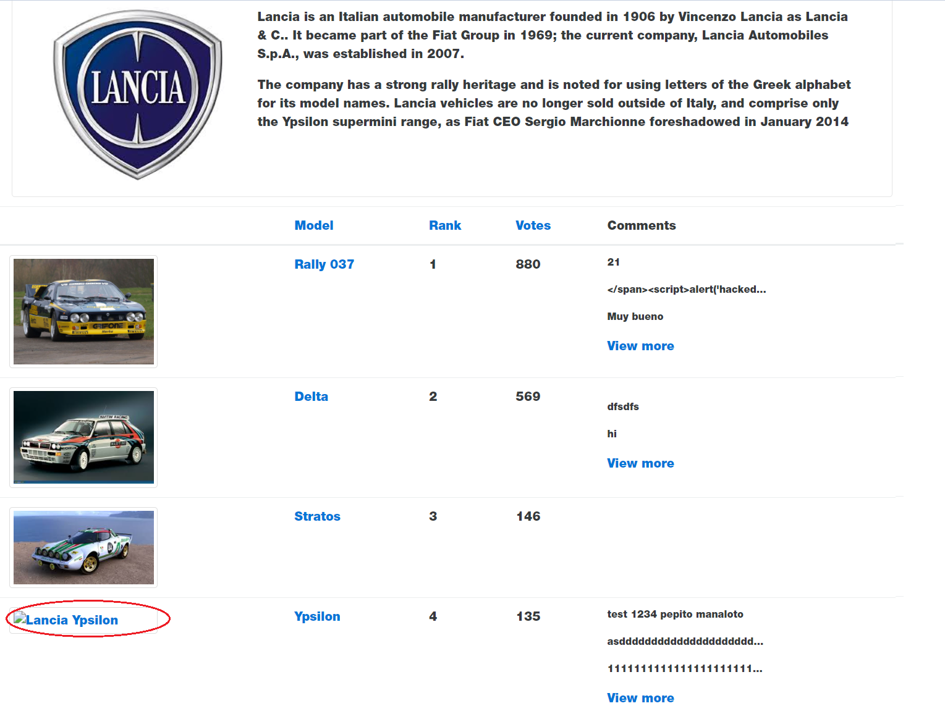  Expected Result:  - All cars should have images  Actual Result:  - Lancia Ypsilon car has a broken image
Current Environment:  (Required) | TEST
Defect Type:  (Required) | Functionality (Default)  Architectural  Connectivity  Consistency  Database Integrity  Documentation  GUI  Installation  Memory  Performance  Security and Controls  Standards and Conventions  Stress  Usability
Who Detected:  (Required) | Quality Assurance (Default)  External Customer  Internal Customer  Development
How Detected:  (Required) | Testing (Default)  Review  Walkthrough  JAD
Assigned To:  (Required) | BCR Dev Team
Priority:  (Required) | High (Default)  Critical  Medium  Low
Severity:  (Required) | High (Default)  Critical  Medium  Low
Status:  (Required) | Open (Default)  In Progress  Resolved  Ready for Testing  Closed  Reopened
Status Description:

Fixed by:
Planned Fix Build #:

